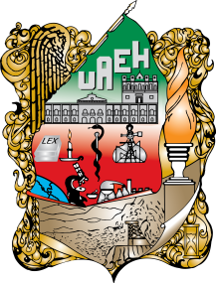

UNIVERSIDAD AUTÓNOMA DEL ESTADO

DE HIDALGO

**NAME OF THE PARTNER INSTITUTION**

**LETTER OF INTENTION**

The Universidad Autónoma del Estado de Hidalgo **“LA UAEH”** has the intention of starting collaboration relations and agreements in the academic, scientific, cultural, and productive fields with the university of ___________________, as well as with the university of _________________________.

Herein, it is recognized the importance of institutional cooperation to achieve common goals and mutual interests, with the purpose of establishing and reinforcing relationships that allow, in a short term, entering into general or specific collaboration agreements between **“THE UAEH”**, and the ______________of ___________________which encourage the interinstitutional cooperation established in the following areas: (for example)

* Development of joint research projects that favor and promote the social development.
* Organization of academic and scientific activities such as courses, conferences, symposiums, etc., that benefit the institutions and the regions or countries.
* Exchange of publications regarding academic development, cultural and entrepreneurial research.
* Mobility of researchers and students between the involved institutions to work on collaborative projects.
* Promotion of education for the development of the university community.

The collaboration projects may include any academic discipline according to the interests of the institutions involved.

This letter of intention may be modified by mutual consent or be terminated by any of the parties through prior notice in writing. This letter will be valid for one year and can be renovated by mutual consent of **“THE PARTIES”**.

This letter of intent was read and signed in duplicate, in Spanish and in (language of the partner institution), in the city of Pachuca, Hidalgo on ____ ___________, 20_____.

|  |  |
| --- | --- |
| **“THE UAEH”**  ______________________________  **Dr. Octavio Castillo Acosta**  President | **“PARTNER INSTITUTION”**  ___________________________ |